<http://time.com/money/4207416/hollywood-wage-gap/>

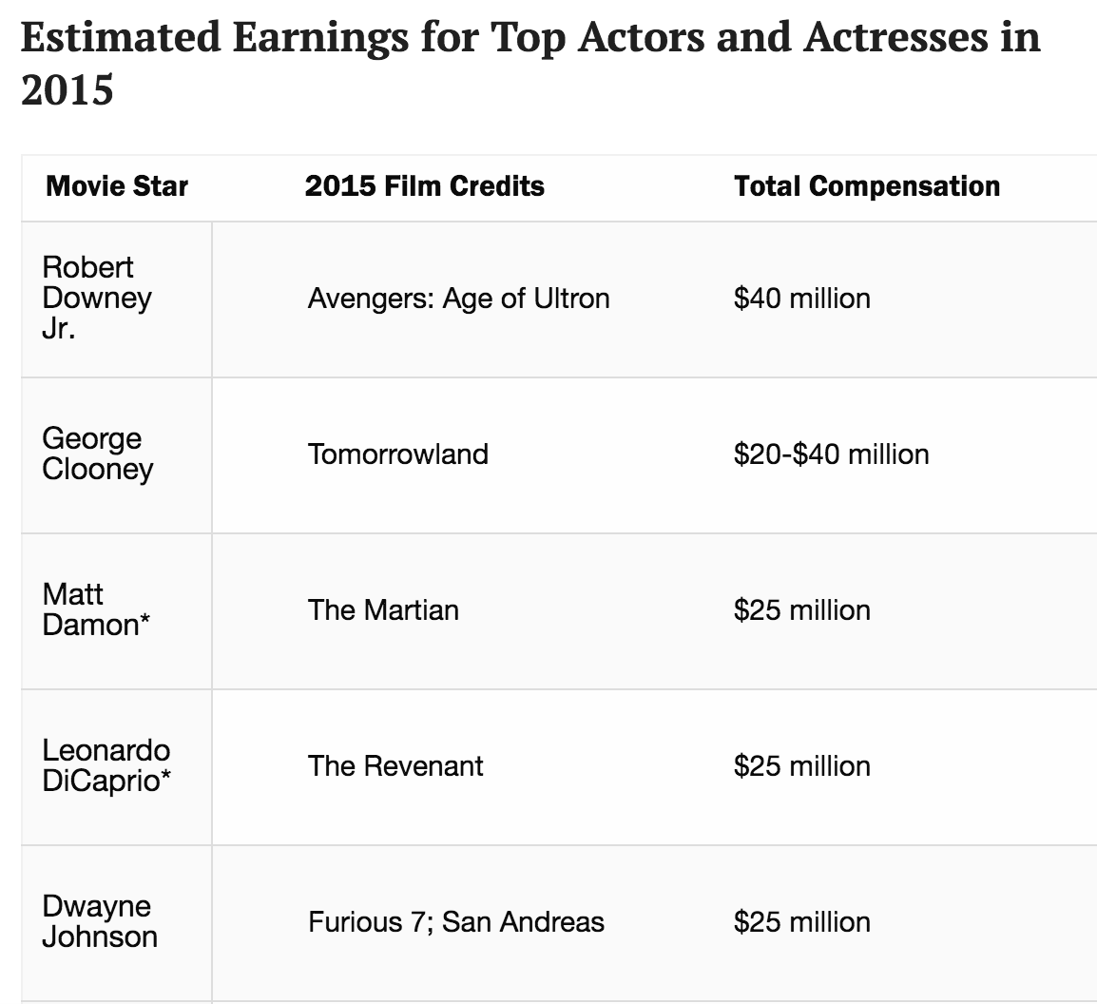

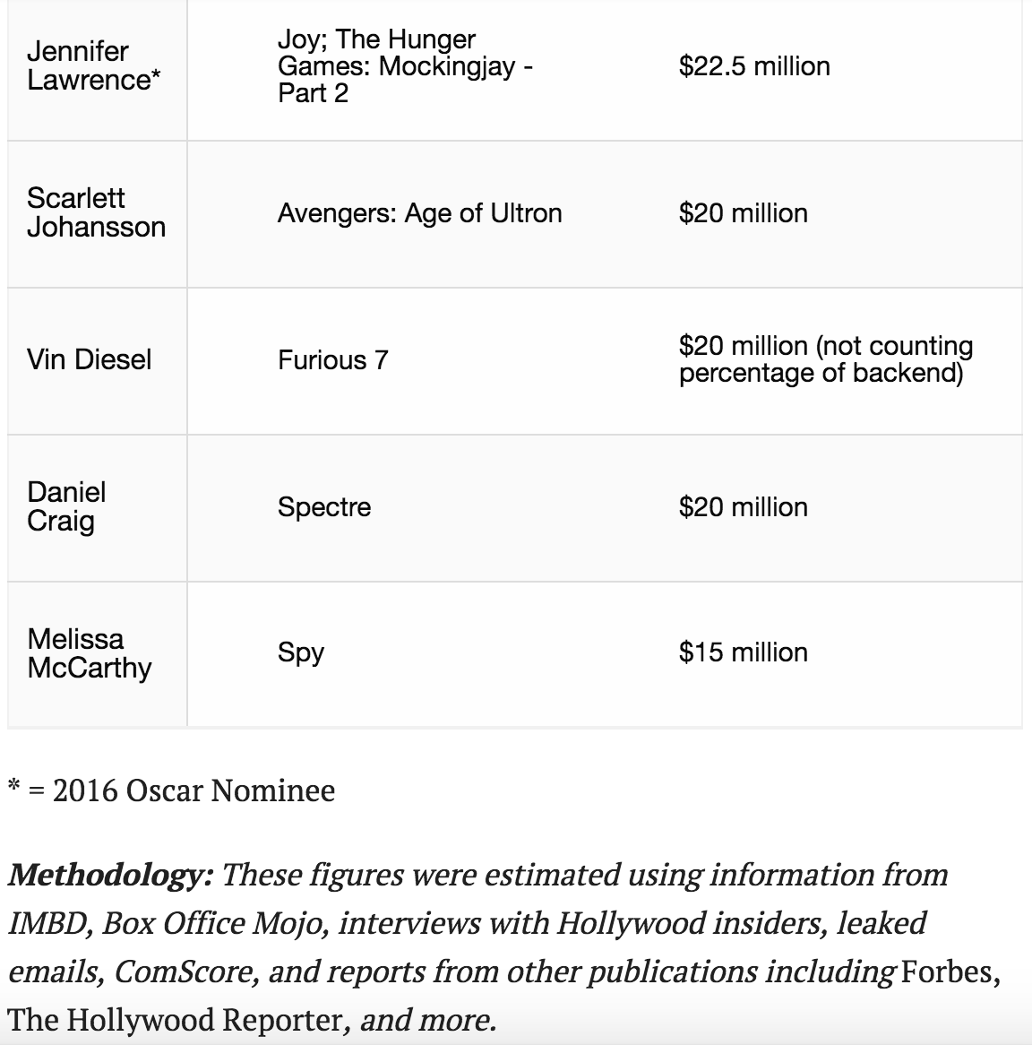

<https://www.theguardian.com/film/2016/aug/25/dwayne-johnson-top-earning-actor-hollywood-pay-gap-forbes>

Website and article supporting the finding that there is a gender gap (in opportunity and employment) <https://seejane.org/research-informs-empowers/data/#B>

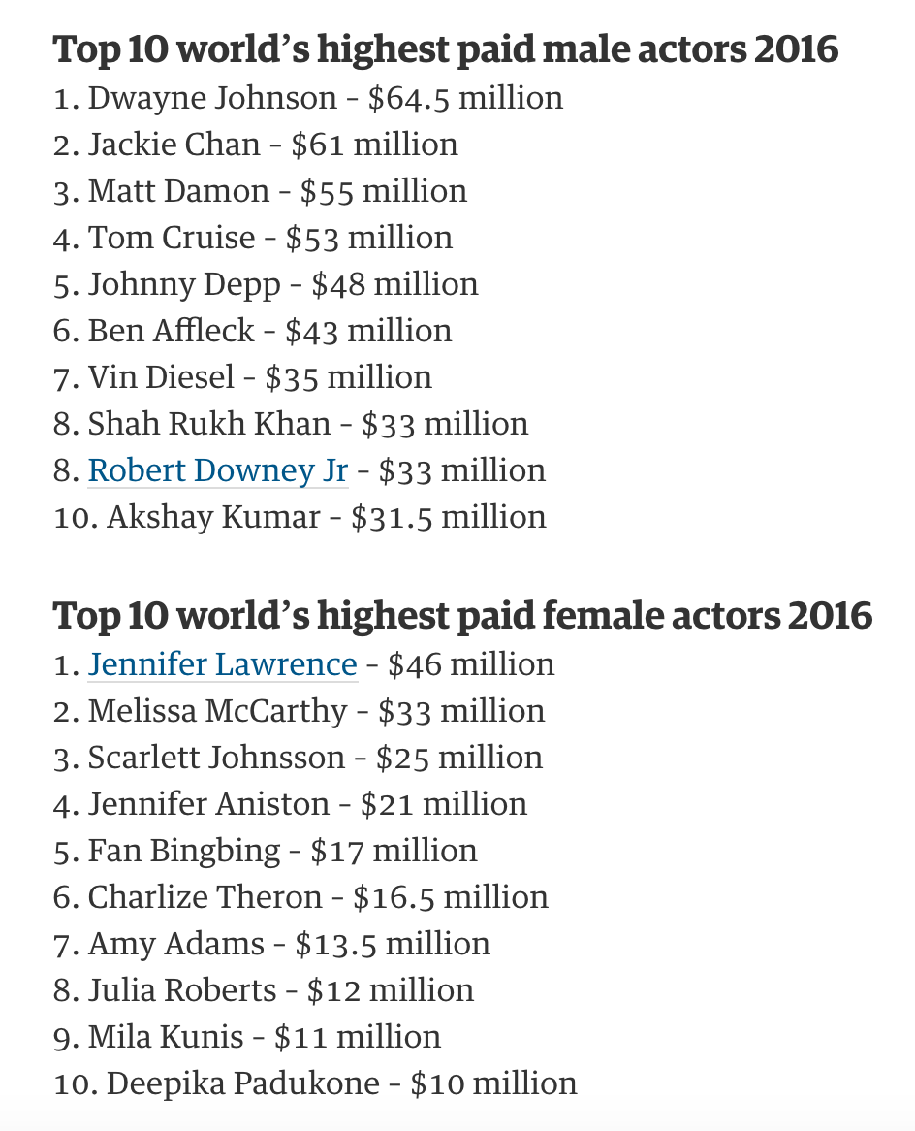

http://datatopics.worldbank.org/gender/indicators

http://www.oneyearmba.co.in/mendoza-research-the-colour-of-money-how-age-gender-influence-hollywood-paychecks/

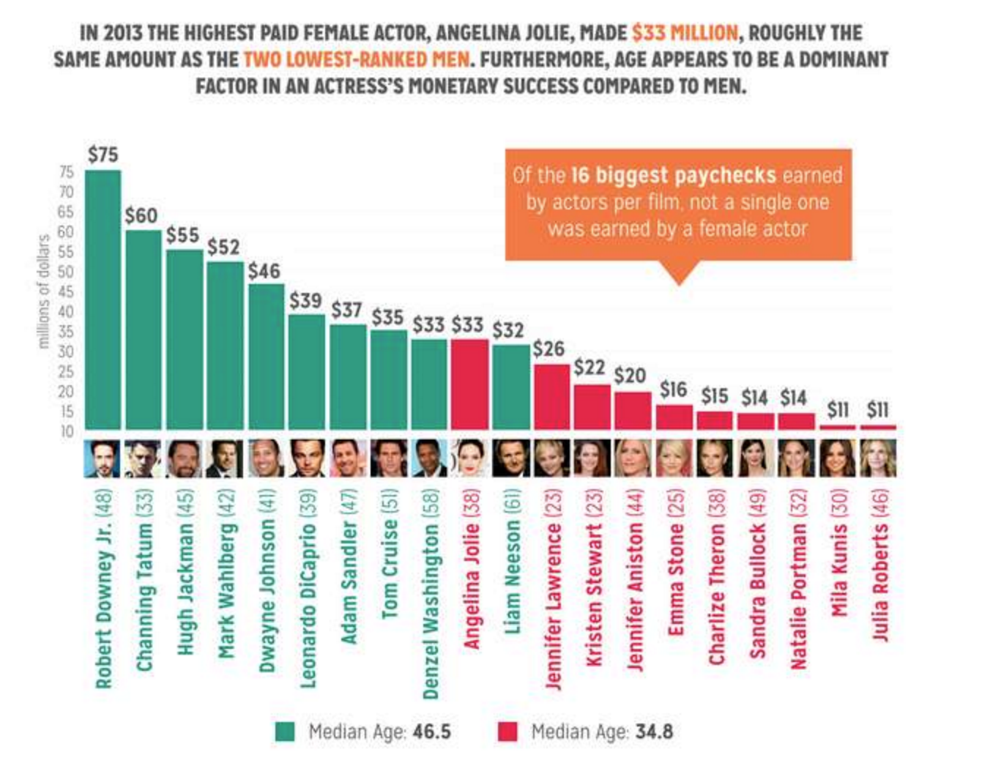

<https://www.census.gov/population/projections/data/national/> - population projections

|  |  |
| --- | --- |
| Claims | Datasets |
| There is indeed an income gap.  How big is the gap? | <https://www.kaggle.com/jonavery/incomes-by-career-and-gender> |
| Which fields have the most difference in pay?  How is pay gap related to advancement in fields? | <https://www.kaggle.com/jonavery/incomes-by-career-and-gender> |
| How does this affect (if at all) country’s economy? | <http://data.worldbank.org/indicator/NY.GDP.MKTP.KD.ZG>  <http://data.worldbank.org/topic/economy-and-growth> |
| Gender equity index | <https://data.europa.eu/euodp/en/data/dataset/gender-equality-index> |

This is for jobs: flexible inflexible jobs

<https://www.stlouisfed.org/on-the-economy/2016/august/job-flexibility-gender-pay-gap>

<https://catalog.data.gov/dataset?tags=salary>

<https://www.glassdoor.com/research/studies/gender-pay-gap/> - known and unknown factors in gender pay gap

<http://datatopics.worldbank.org/gender/indicators>

<https://www.bls.gov/news.release/pdf/ocwage.pdf> - pdf for hourly wage

<https://fivethirtyeight.com/features/u-s-women-are-stronger-in-the-tennis-world-than-u-s-men/>

# **U.S. Women Are Stronger In The Tennis World Than U.S. Men**

https://github.com/PurnimaTripathi

References:

<https://factfinder.census.gov/faces/tableservices/jsf/pages/productview.xhtml?pid=ACS_15_5YR_B15002&prodType=table>

<http://www.aauw.org/research/the-simple-truth-about-the-gender-pay-gap/>

# **Yes, men earn more than women. Except in these jobs**

<http://money.cnn.com/2016/03/23/pf/gender-pay-gap/index.html>

